**Case Study: Performance Monitoring and Analysis with JMeter, Prometheus, and Grafana**

**Url : casekaro.com**

**Created Test Plan : Casekaro Test Plan**

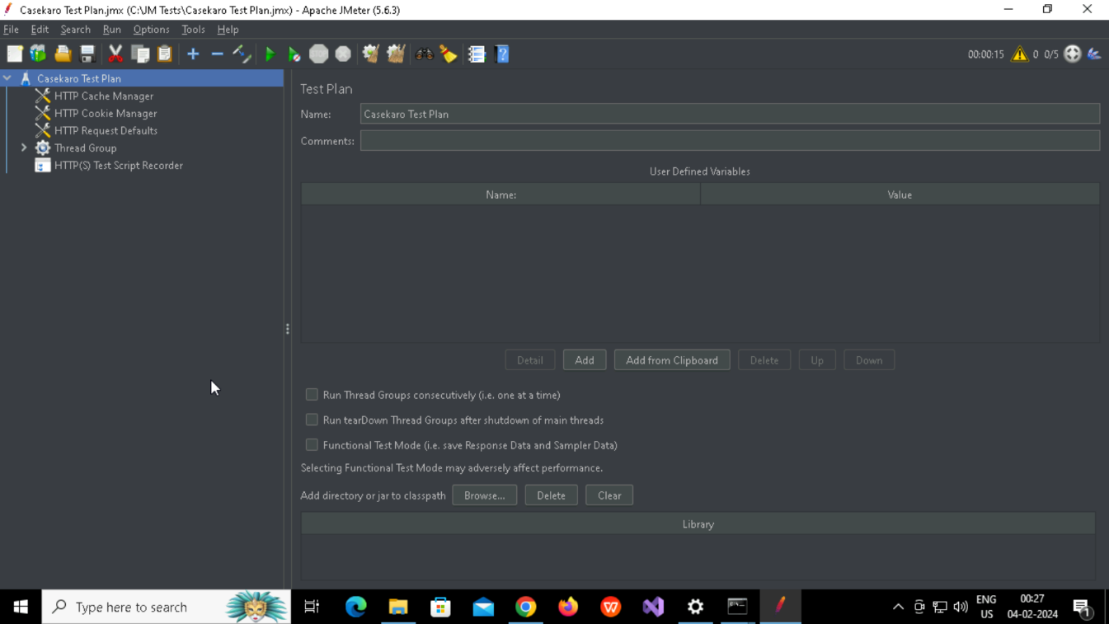

**Created Http Cache Manager**

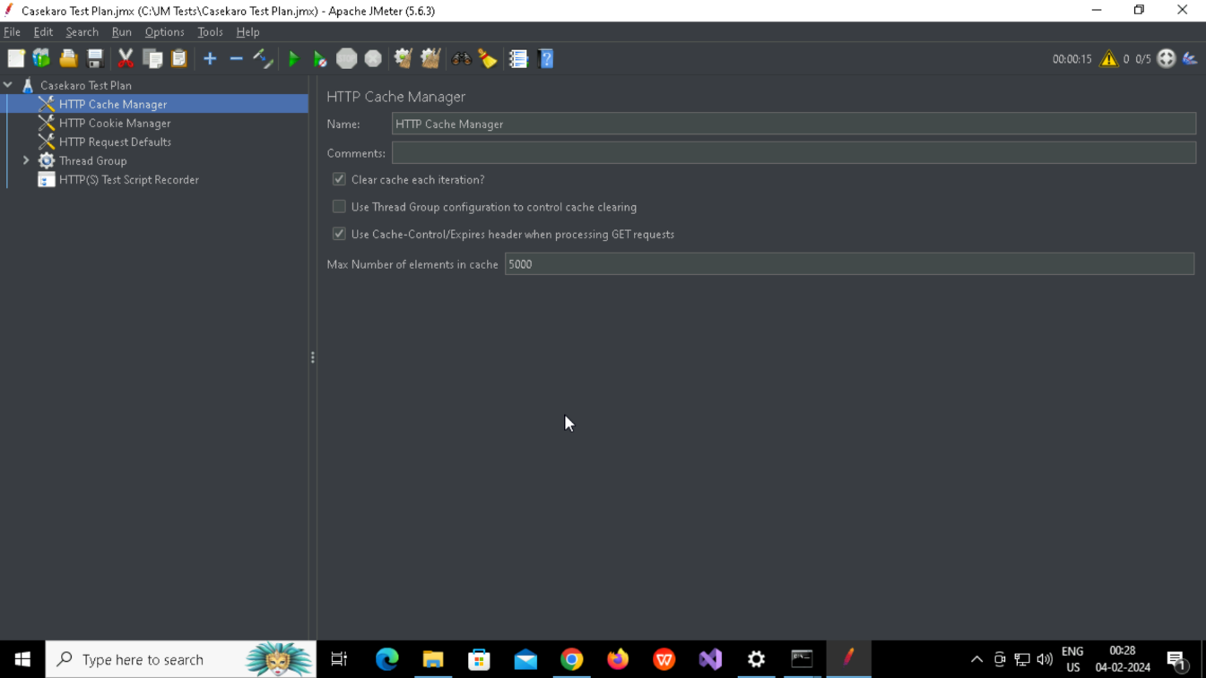

**Created Http Cookie Manager**

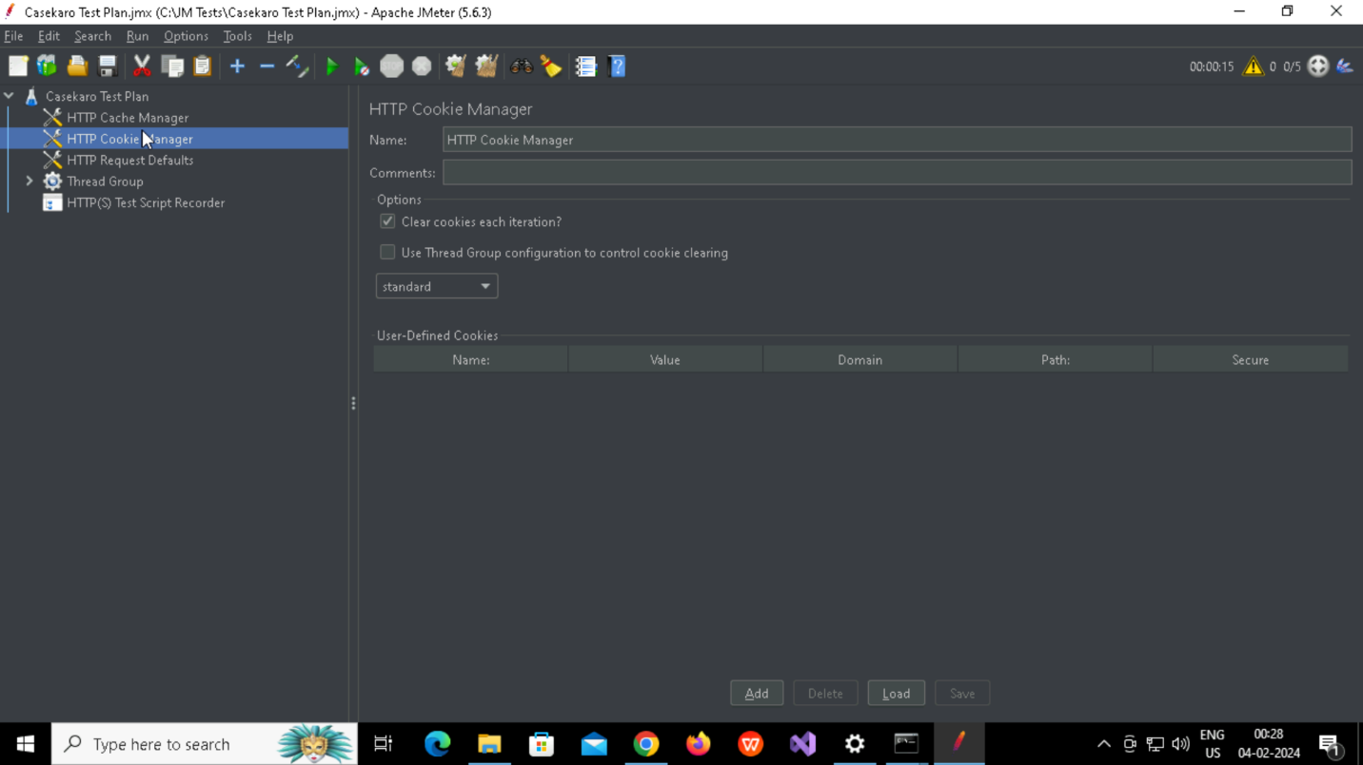

**Created Http Request Defaults**

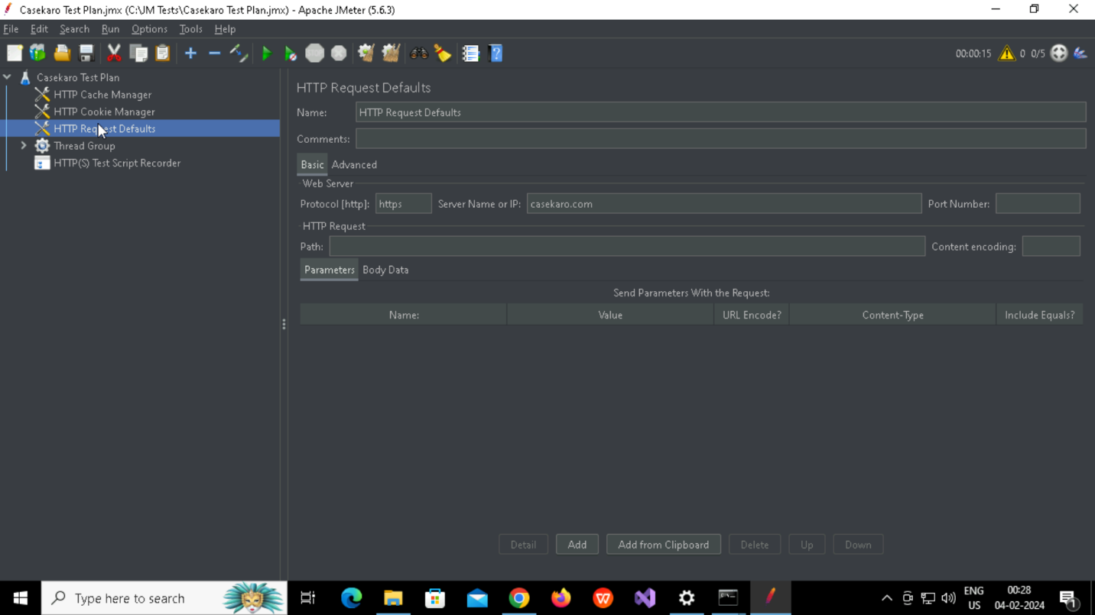

**Created Http Thread group and Recording Controller named Home**

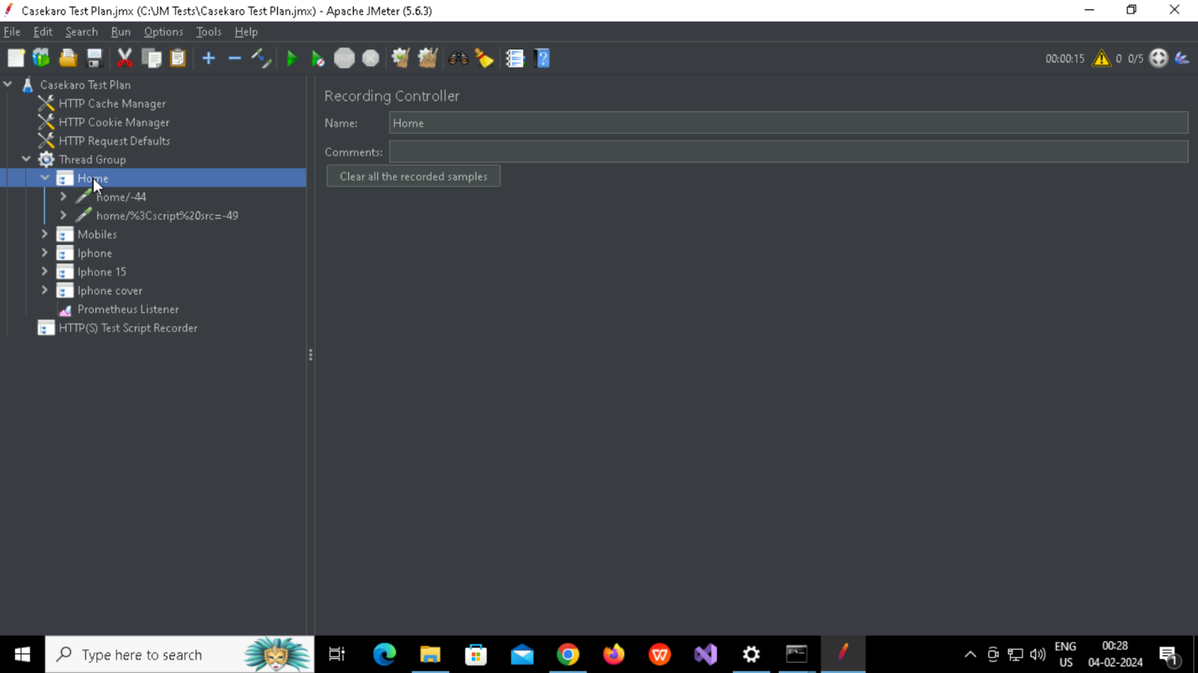

**Created Http Thread group and Recording Controller named Mobiles**

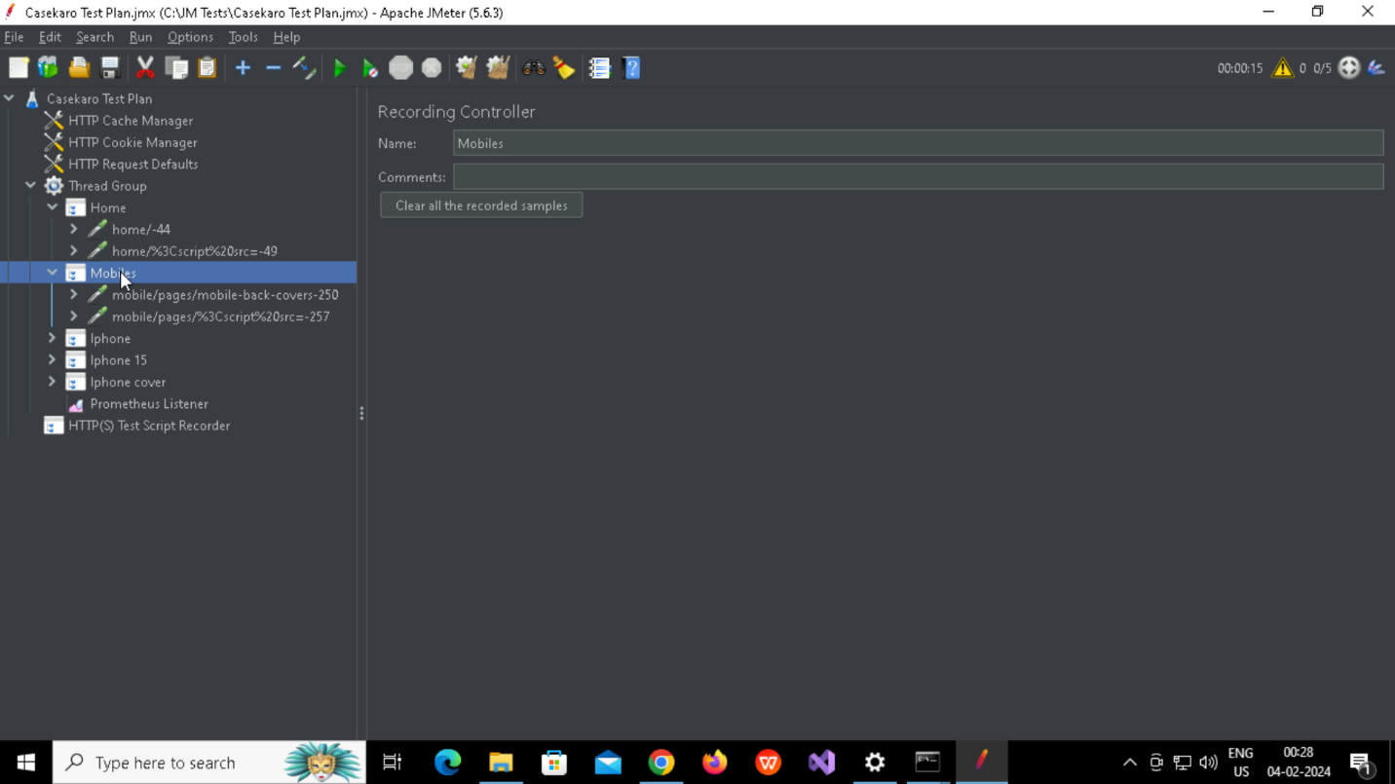

**Created Http Thread group and Recording Controller named Iphone**

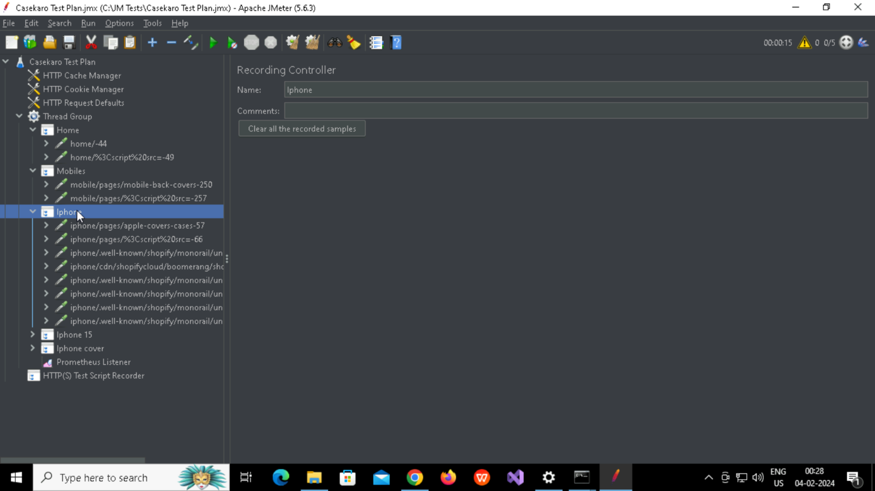

**Created Http Thread group and Recording Controller named Iphone 15**

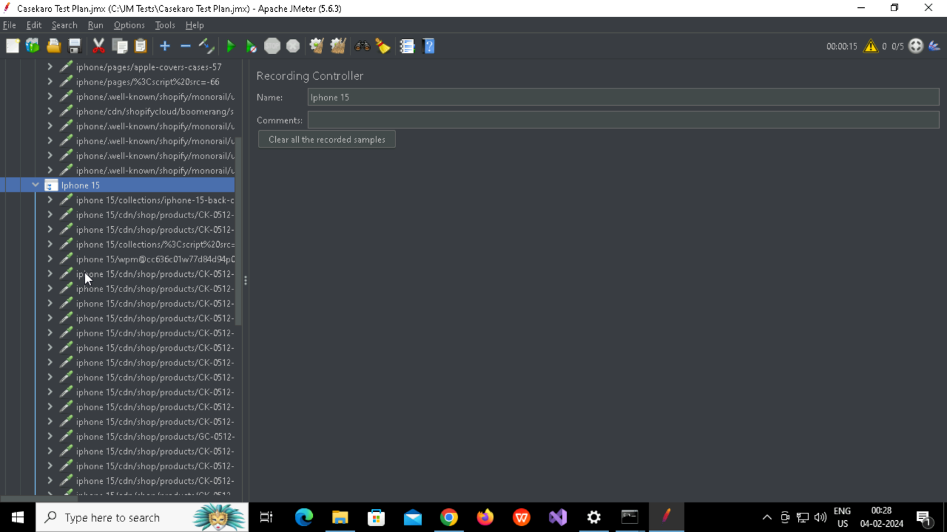

**Created Http Thread group and Recording Controller named Iphone Cover**

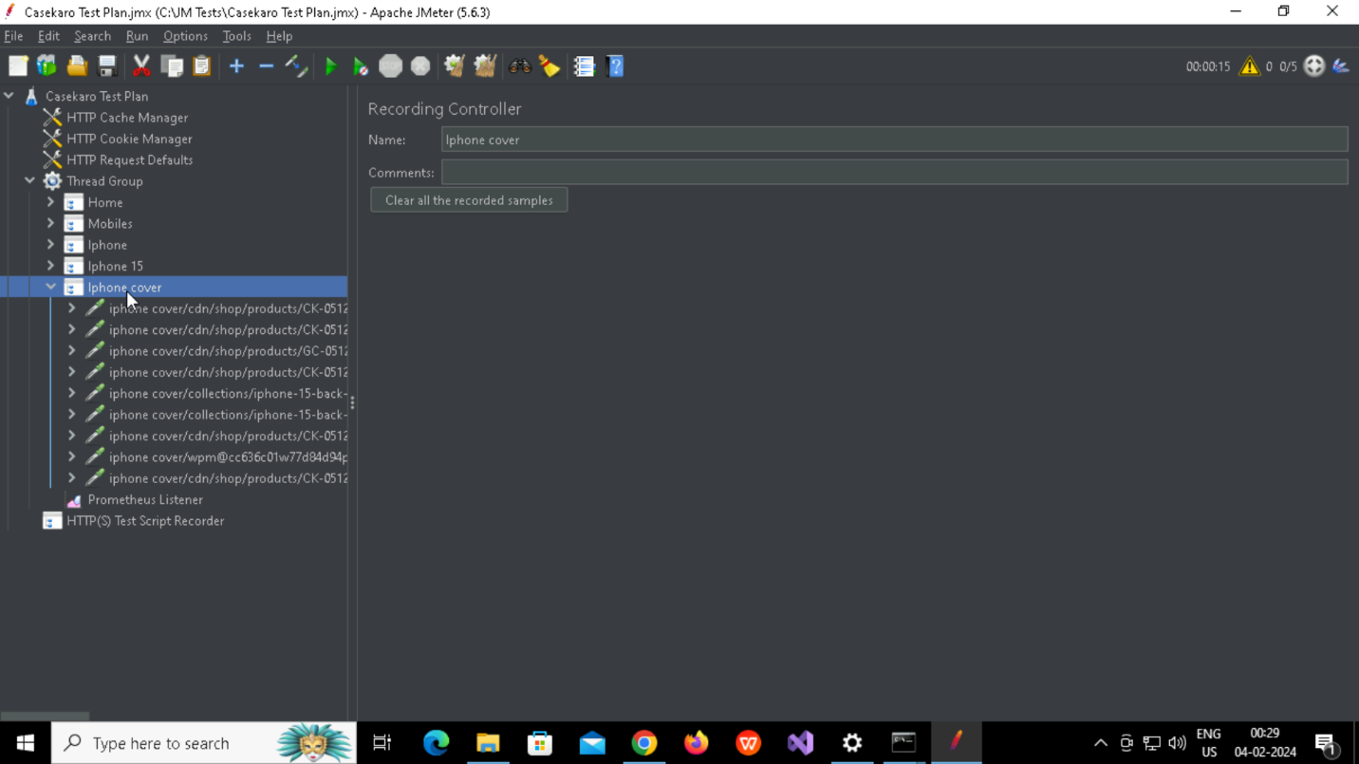

**Created Prometheus Listener**

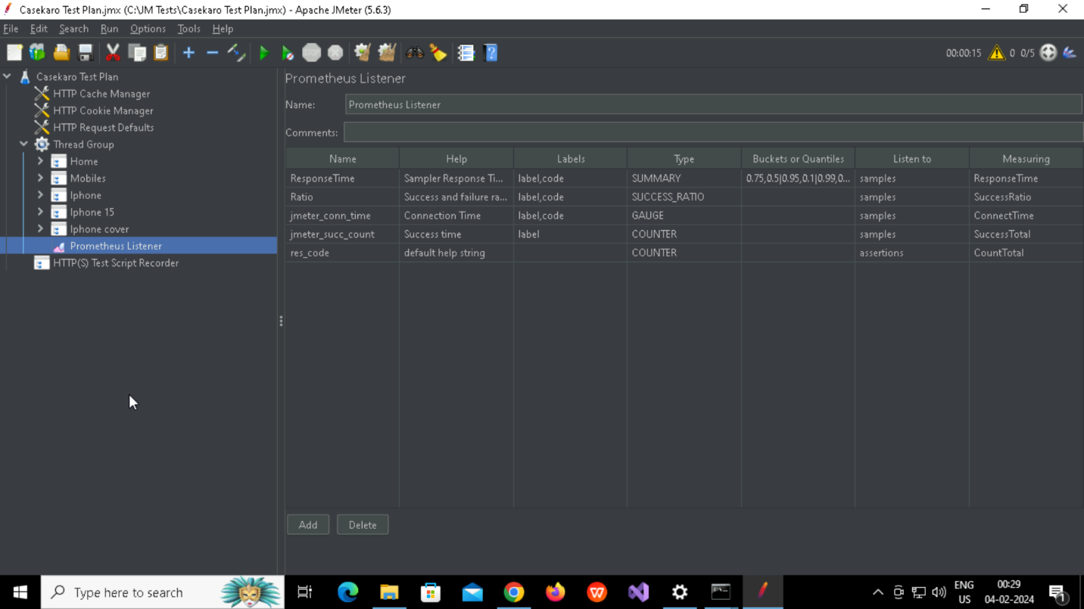

**Created Http Test Script Recorder**

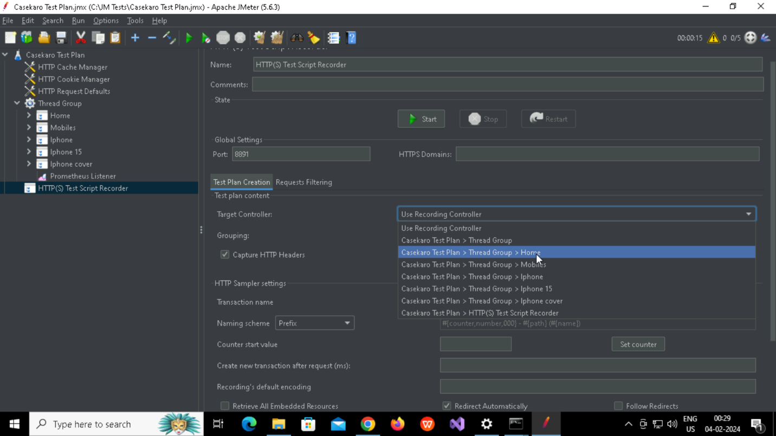

**Prometheus Targets**

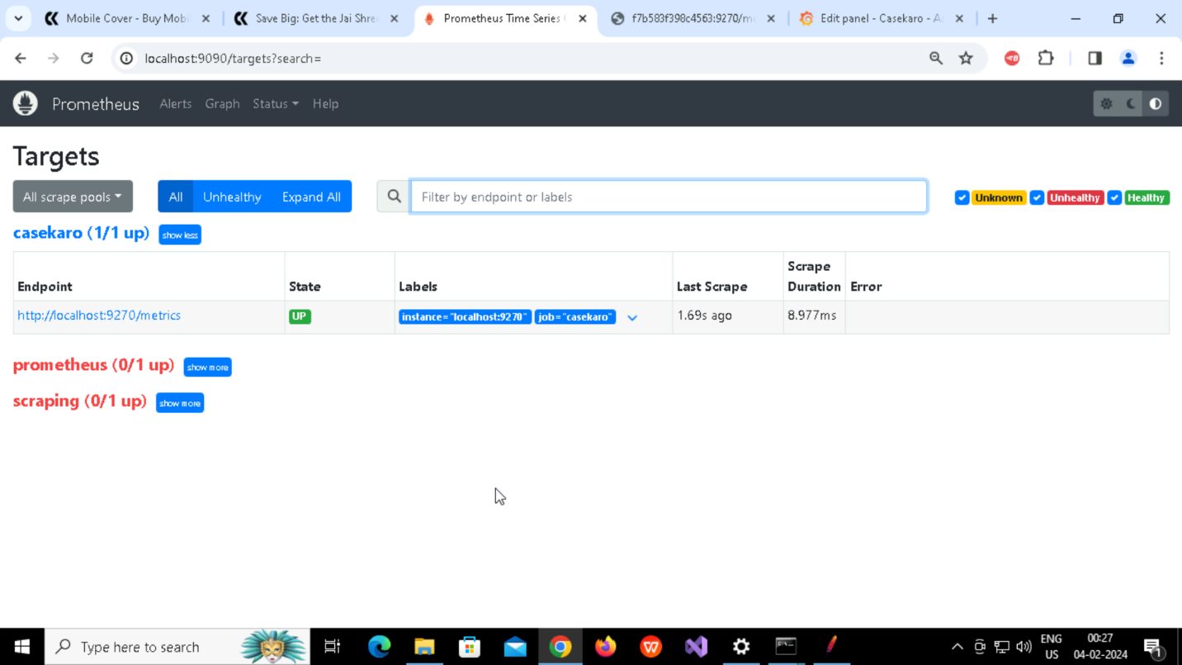

**http://localhost:9270/metrics**

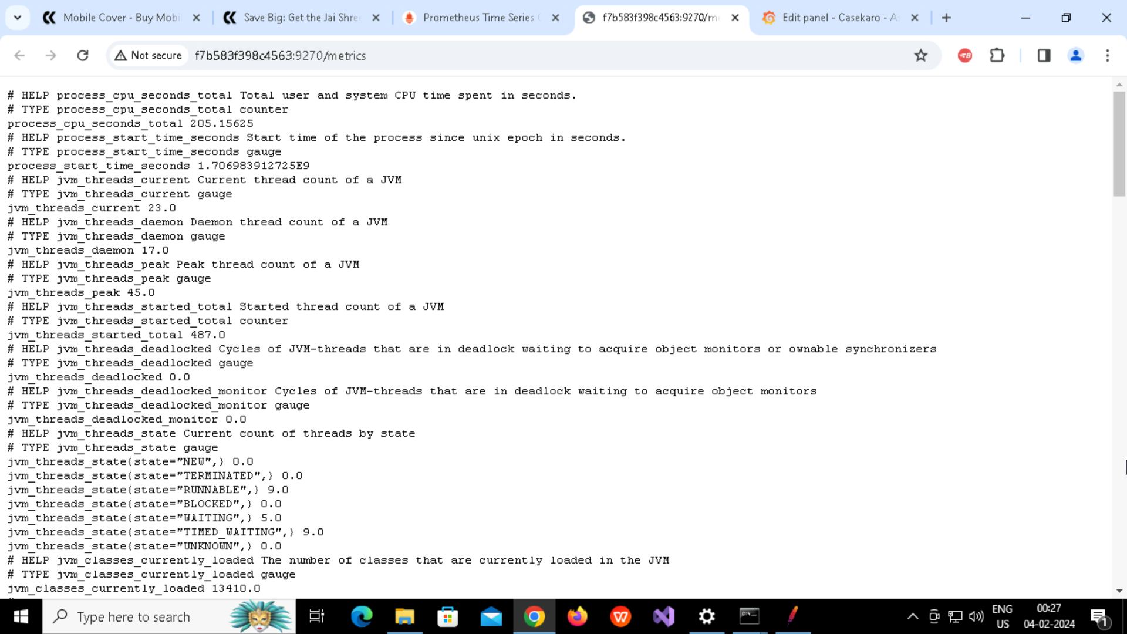

**Created Alerts**

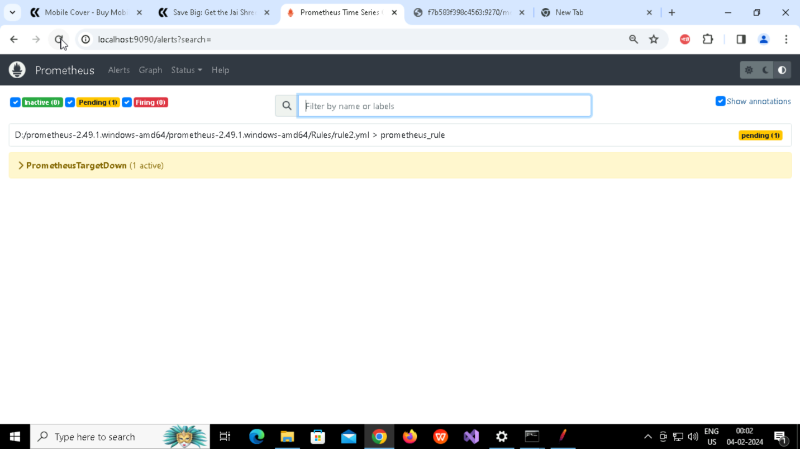

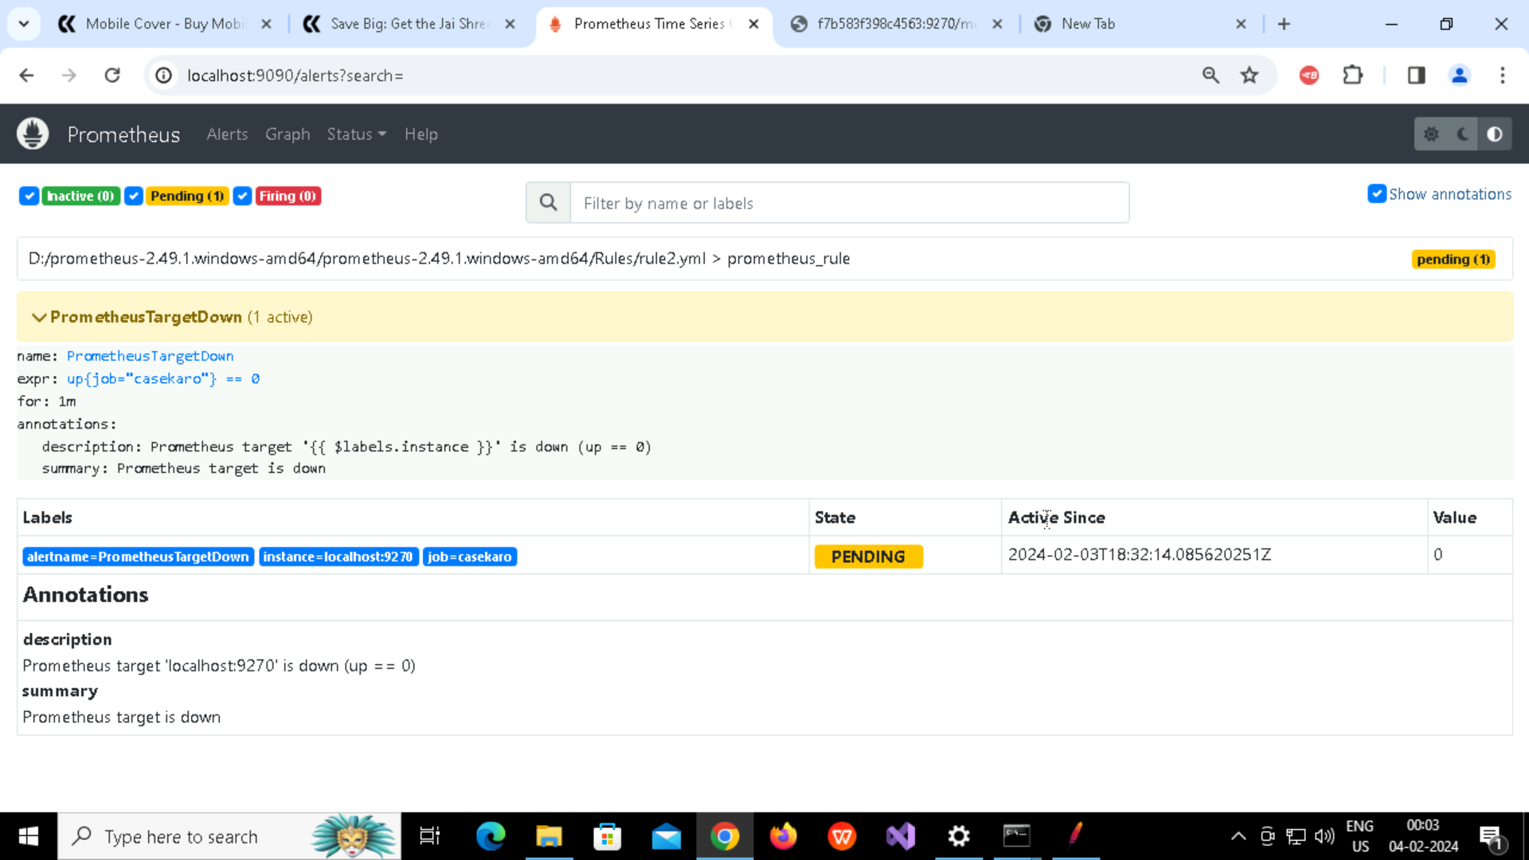

**Created Panel with Gauge**

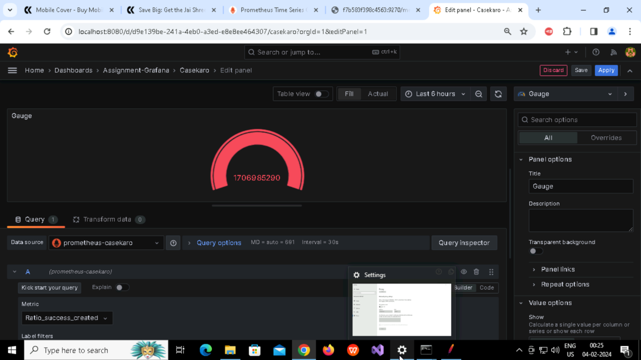

**Created Panel with Table**

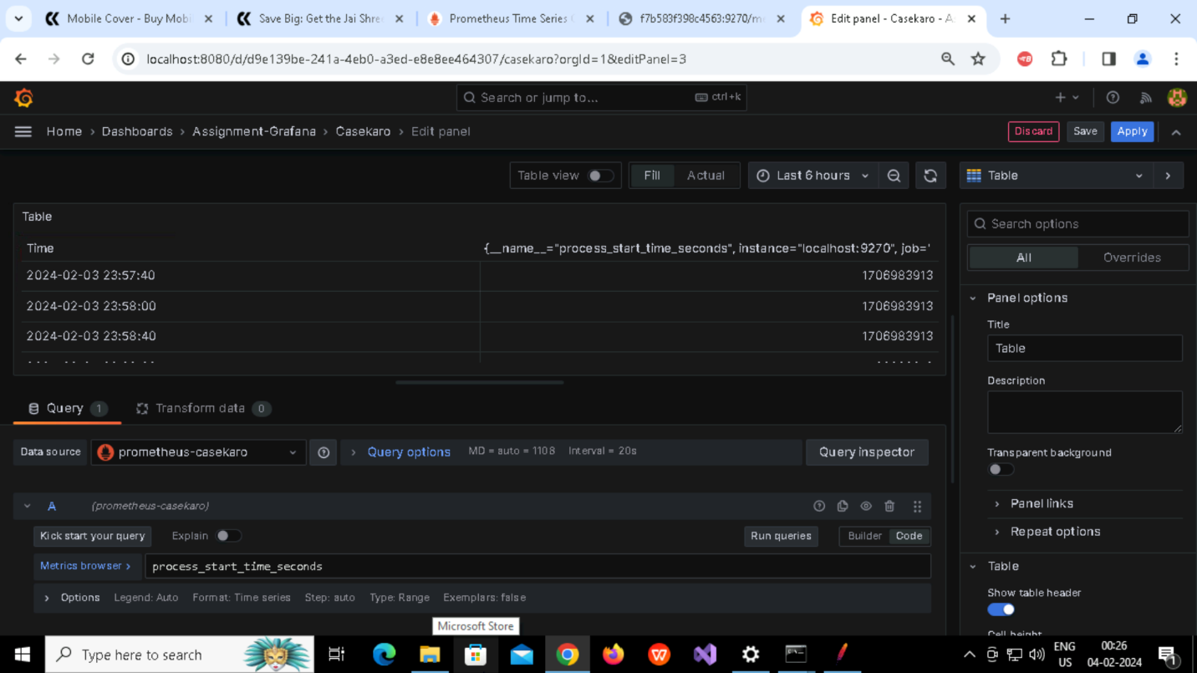

**Created Panel with Barchart**

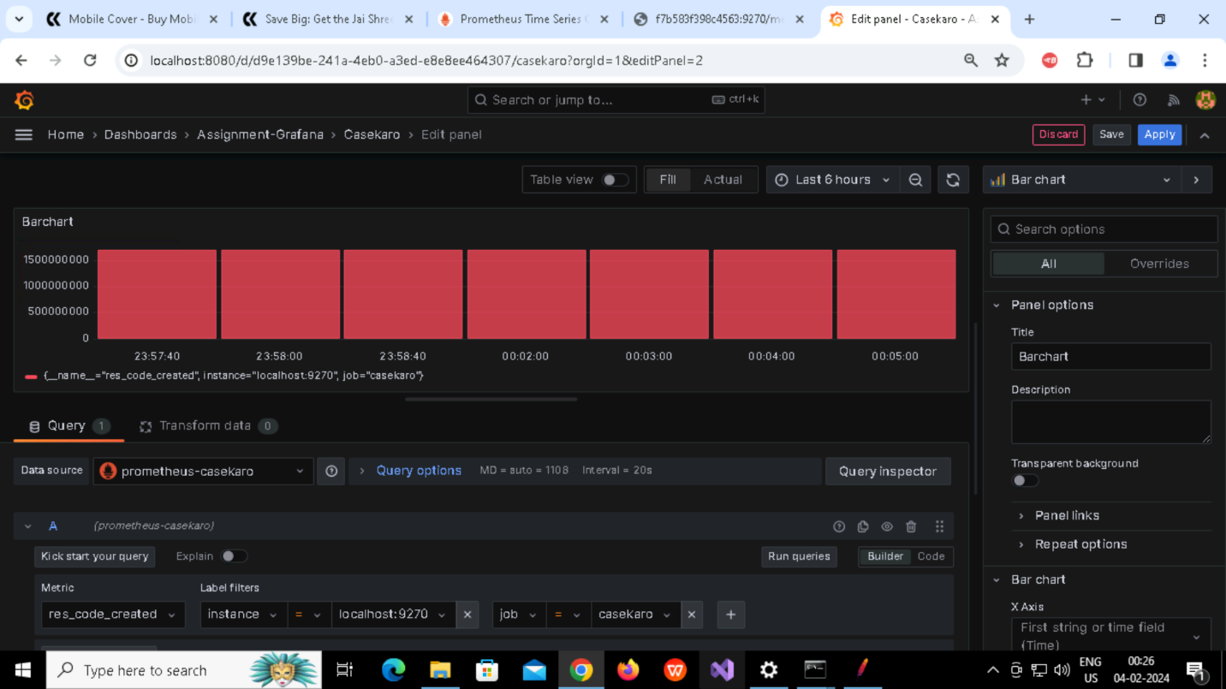

**Created Panel with Bar Gauge**

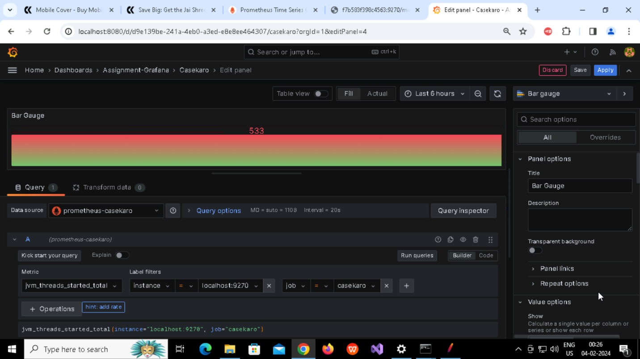

**Created Dashboard**

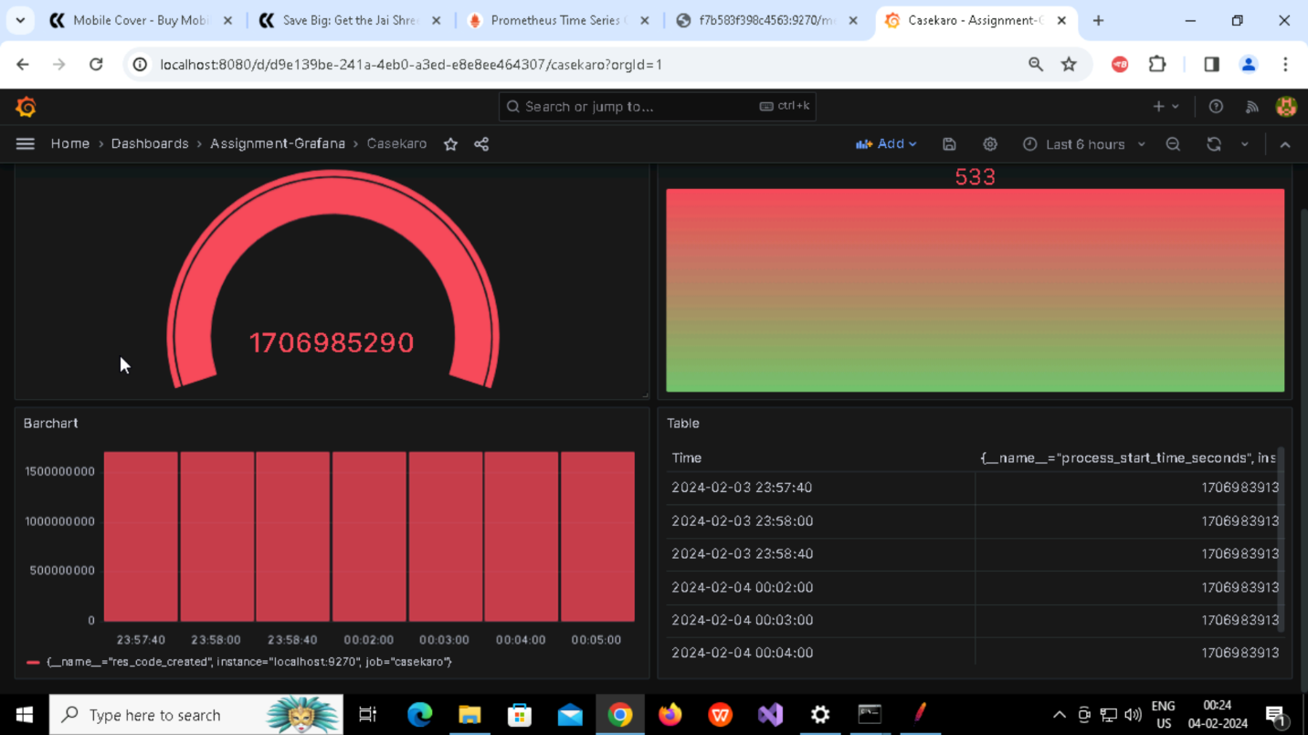

**Creating logs and reports using GUI**

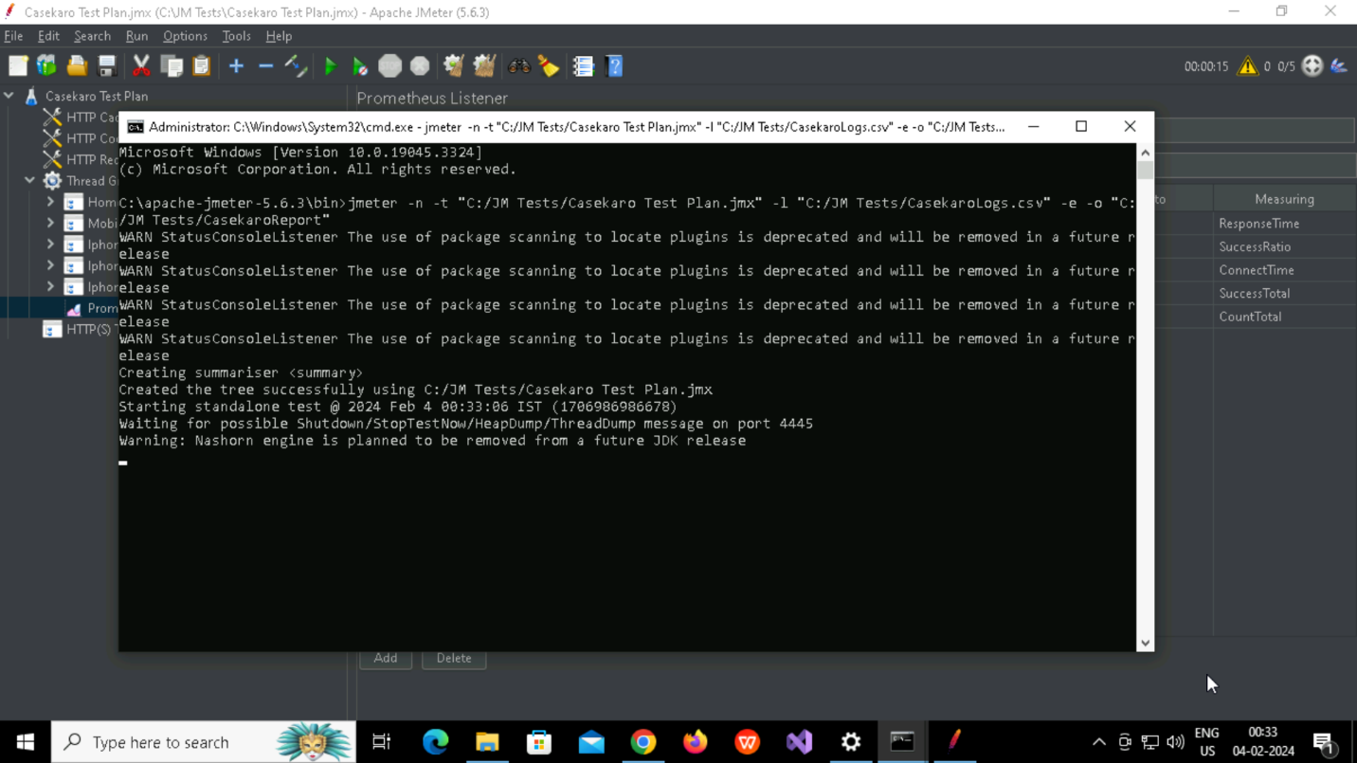

**Created Casekarologs.csv file**

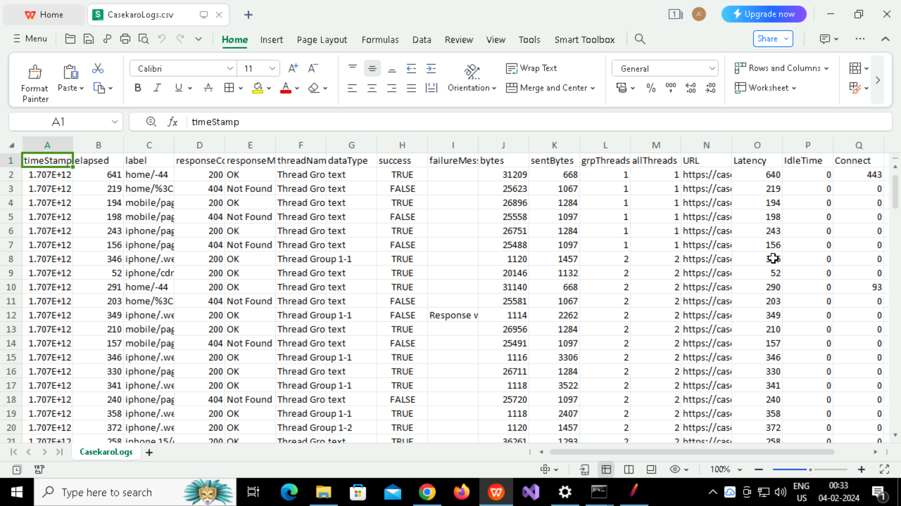

**Created CasekaroReports**

